Bleasby
Local
History
Society
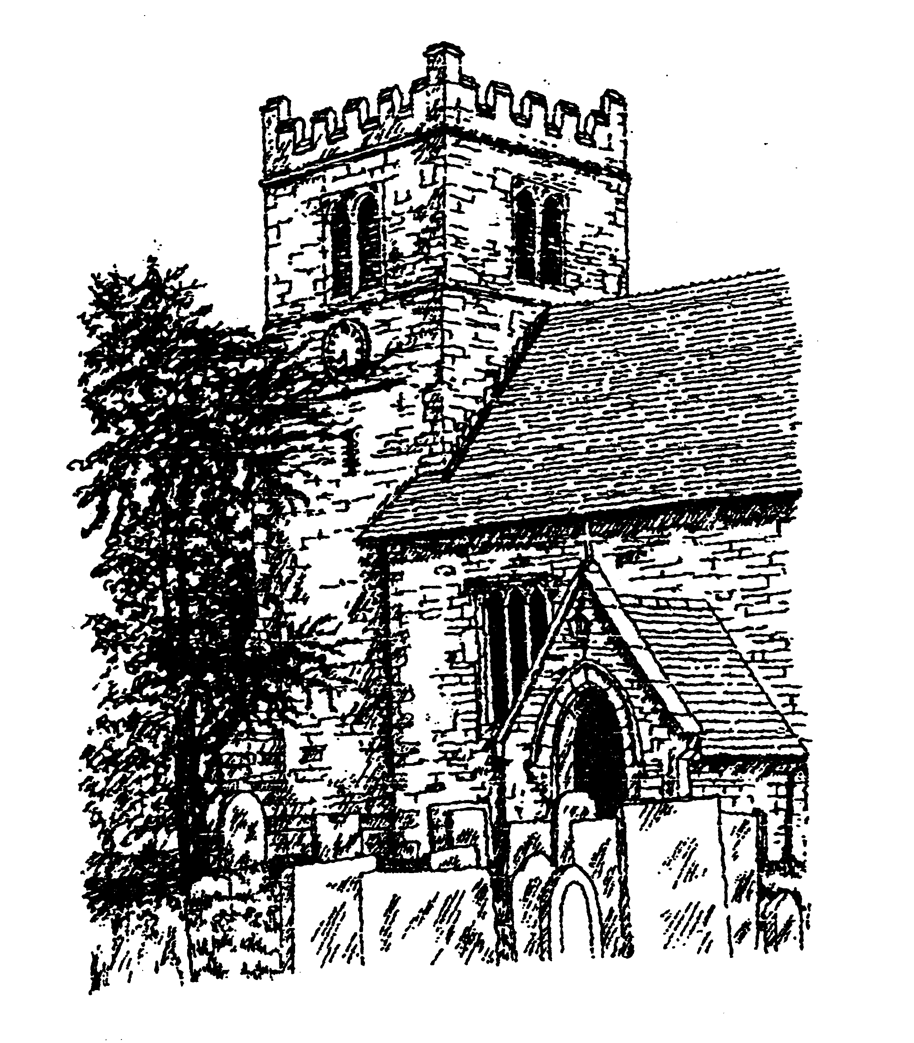

Tuesday 27th July 2021

The Parks and Gardens of Nottinghamshire

A talk by Jason Mordan, Senior Conservation Officer, Notts County Council

7.30pm in the Village Hall with careful seating arrangements, ventilation and face coverings desirable if appropriate

Small fee requested for non-subscription members

